Case Study - How Can a Wellness Technology Company Play It Smart?

**Author:Prashant Joshi**

Date: 07/11/2024



Table of Contents

Introduction ........................................................................................................................... 5

Business Task.......................................................................................................................... 5

Objectives (Ask) ..................................................................................................................... 5

Key stakeholders .................................................................................................................... 5

Scope of the study ................................................................................................................. 6

Methodology ......................................................................................................................... 6

Literature Study ..................................................................................................................... 6

Prepare .................................................................................................................................. 8

1) Fitabase Dataset ................................................................................................................ 8

2) MI Band Data set ............................................................................................................... 9

3) MI Fitbit dataset ................................................................................................................ 9

Process .................................................................................................................................. 9

Analyse ............................................................................................................................... .10

Conclusion ........................................................................................................................... 15

Recommendations (Share) .................................................................................................. 16

References .......................................................................................................................... 18

List of Figures

Figure 1: Ways of accessing health apps world-wide by 2017 ............................................... 7

Figure 2: Top Metrics tracked by U.S wearable device users, March 2021 ........................... 8

Figure 3: Metrics tracked by Fitabase respondents .............................................................. 11

Figure 4: Average duration per activity when tracking device was used .............................. 12

Figure 5: Average hourly intensity ........................................................................................ 13

Figure 6: Daily average steps............................................................................................................... 14

LIST OF TABLES

Table 1: Change Log........................................................................................................... 10

Table 2: Average heart rate per minute ............................................................................................ 15

Introduction

Bellabeat is a high tech manufacturing company that is focused on health products for women. It was founded in 2013 by Urška Sršen and Sando Mur. It has grown to be one of the successful small tech companies, by 2016 the company has opened many offices around the world and has launched multiple products. Some of their products include Bellabeat app , Leaf (a wellness tracker that can be worn as a bracelet, necklace or clip), Time (a wellness watch) and Spring (a water bottle that tracks daily water intake). These products track users’ physical activities, sleep, stress, menstrual cycle and mindfulness habits.

Bellabeat aims to empower women with the knowledge about their own health and habits. It offers subscription membership-based to its clients and provide them with around the clock access to fully personalised guidance on nutrition, activity, sleep, health, beauty and mindfulness based on their lifestyles and goals.

The company’s objective is to become a larger player in the global smart device markets. It has invested heavily on traditional advertising media and it maintains its presence by engaging its clients and/ or potential clients on social media platforms.

Business Task

Analyse smart device data usage in order to gain insight into how consumers use non-Bellabeat smart devices and use those insights to guide Bellabeat’s marketing strategy.

Objectives (Ask)

• Identify trends on non-Bellabeat smart device usage

• Find ways to connect these trends to Bellabeat customers

• Identify ways that these trends can help to influence Bellabeat marketing strategy

Key stakeholders

• **Urška Sršen:** Bellabeat’s co-founder and Chief Creative Officer

• **Sando Mur:** Mathematician and Bellabeat’s co-founder; key member of the Bellabeat executive team

• **Bellabeat marketing analytics team:** A team of data analysts responsible for collecting, analyzing, and reporting data that helps guide Bellabeat’s marketing strategy.

Scope of the study

The study is limited to analysing public datasets from non Bellabeat tracking devices.

Methodology

Follow Google Analytics methodology in analysing datasets. The phases of data analysis followed are as follows:

1. Ask

2. Prepare

3. Process

4. Analysis

5. Share

6. Act

Literature Study

The global market for health smart device is expected to grow and reach 114.36 billion in USD by 2028 (Fortune Business Insights, 2021). It is reported that one in three Americans have used at least one of the health digital products. According to a study done in 2019, about 19% of Americans were currently using wearable fitness trackers, with some using mobile health apps or combination (Justin Mccarthy, 2019).

According to the study done in 2017, the top 3 ways in which people accessed health apps world-wide were Phone-based apps, web-based apps and wearable devices, refer to Figure 1 below (John Elflein, 2019)

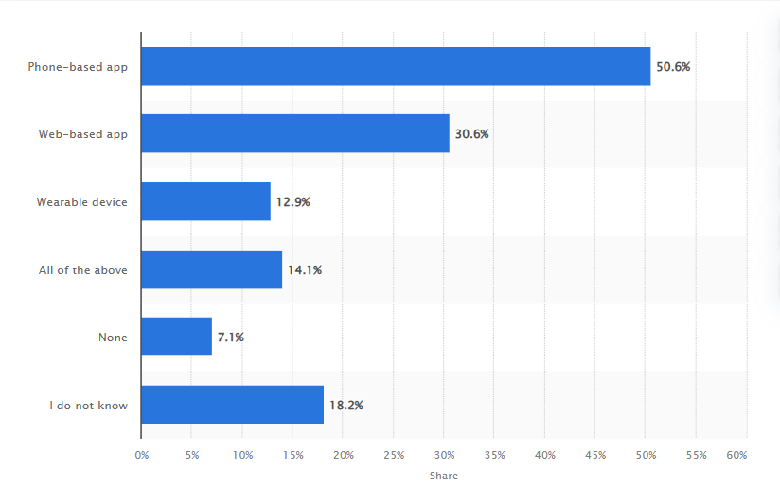 ***Figure 1. Ways of accesing health apps worldwide***

In the United States, as of **2023**, the use of wearable fitness or wellness technologies showed a fairly balanced distribution between genders.

* Women had a slightly higher usage rate at **35**% compared to men, who had a usage rate of **34**%.
* This near parity in the statistics indicates that both genders are almost equally engaged in utilizing wearable technologies to monitor and enhance their health and wellness, reflecting a broad acceptance and integration of these devices across different demographic groups.

The leading metrics among US wearable users are fitness-related: **59%**count on these devices to tally their daily steps, and **42%**use the tech to track workouts. Meanwhile, just **8%**monitor chronic health conditions with smartwatches, fitness trackers, and the like.in the figure below

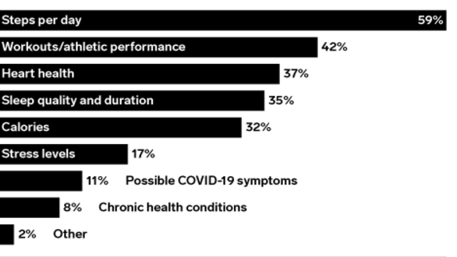

Figure 2: Top Metrics tracked by U.S wearable device users, March 2021

The literature study shows that there is a market for health smart device trackers and this market is expected to grow. There are major players dominating the market however there is still room for smaller players to grow. There is opportunity to capture those users who have stopped using health apps, capture new clients who have never used health tracking devices as digitization rate continues to grow and/ or capture clients using other applications by offering them cutting edge applications and comprehensive health products.

Prepare

1) Fitabase Dataset The main dataset used for analysis is from Kaggle (<https://www.kaggle.com/datasets/arashnic/fitbit>). It contains 18 CSV files with data provided by thirty three eligible Fitbit users. The users consented to the submission of personal tracker data and made it available to the public. The dataset has some limitations as discussed below:

• Outdated: last updated 4 years ago. The data was collected 8 years ago in 2016.

• Short duration; Only 31 days (i.e. 2016/04/12 to 2016/05/12)

• Small sample; Only 33 respondents compared to a global population of fitness tracker users.

• No gender description; since Bellabeat is mainly focused on women health products, dataset dominated by women respondents would have been more relevant.

* No geological location provided; there might be sampling bias if the users are all concentrated in one geological location.

2) MI Band Data set

A dataset Source on kaggle (<https://www.kaggle.com/datasets/damirgadylyaev/more-than-4-years-of-steps-and-sleep-data-mi-band>). A user uploaded the dataset containing his physical activity and sleep monitoring data. The dataset contains data from 27/04/2016 to 14/01/2023. Device used Mi Band Xiaomi. Issues with dataset:

• 15 days have zero values. Users claims values were corrupted.

• Some sleep days were not recorded. The user claims that he was sleeping during the day and the device does not measure day sleeping.

3) MI Fitbit dataset

A data set uploaded on Kaggle (<https://www.kaggle.com/datasets/parulgarg123/mi-fitbit-dataset>) by a user. It contains physical activity data, sleep and heart rate data for a period of one year. The data was recorded using MI Fitbit device. Data recorded from 2018/09/29 to 2019/11/18. Issues with dataset:

• Many data points have duplicates.

Process

Fitabase dataset is part of the study done by a credible organisation. It has few errors that were fixed as summarised in Table 1 below. The other two datasets are uploaded by individuals and had limitations to a greater extent compared to Fitabase dataset.

Table 1: Change Log

|  |  |  |
| --- | --- | --- |
| **Date** | **Dataset** | **Activity** |
| 2/11/2024 | Fitbit Dataset | Merged all Hourly Activities into a single spreadsheet using Excel |
| 3/11/2024 | Fitbit Dataset | Loaded Dataset to Microsoft SQL Server. Some datatypes loaded Incorrectly |
|  |  | Corrected Data Types on SQL. Values loaded as strings instead of Floats or Integers. |
| 5/11/2024 | Fitbit Dataset | Split Datetime |
|  |  |  |
| 8/11/2024 | MI Band Xiaomi | Modified column headers |
|  |  | Converted distance from metres to kilometres |
|  |  | Remove dates with zero values when analysing sleep pattern |
|  |  |  |
| 9/11/2024 | MI Fitbit | Removed 269 duplicates on activity and sleep file |
|  |  | Removed null values/ zero values |

# Analyse

Fitabase data set had 33 respondents which is a small sample in relation to the population that uses health tracking devices. The literature study and the other two dataset are used to complement the study. The conclusions reached will be base on the information provided by this study.

33 respondents submitted their tracking device data from 12/04/2016 to 12/05/2016 which is 31 days in total. On average the device was used for 29 days with only one responded that had used the device for only 4 days. All respondents used their tracking devices to record:

* Total steps
* Distance and time covered while doing

o Very active activities

o Moderate active activities

o Light active activities

o Sedentary activities

* Total calories burned

24 out of 33 respondent or 73% of the responded used their devices or had devices that could track their sleeping patterns. They monitored their sleep for an average of 17 days.

14 respondents or 42% recorded their heart rate and only 8 respondents or 24% recorded or provided their weight measurements. Figure 3 below shows this data graphically.

Respondent of dataset 2 (MI Band Xion) tracked the above metrics excluding weight and heart rate and respondent of dataset 3 (MI Fitbit) tracked the above metrics excluding weight only.

Days the activities were tracked is 2114 for dataset 2 and 179 for dataset 3.

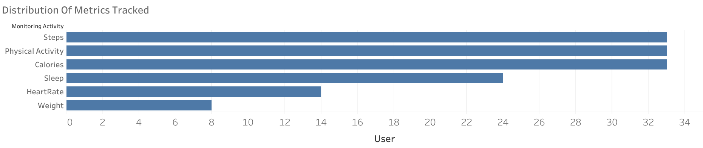

*Figure 3: Metrics tracked by Fitabase respondents*

On average, respondents (Fitabase dataset) used their devices for 20 hours 18 minutes a day (refer to Figure 4 below). They spend 81% of those hours being physically inactive (sedentary active). Sedentary activities can include watching television, using a computer at the office, sitting while commuting or sleeping. When adjusting for sleep, respondents spent 78% while awake being Inactive, that is 8 hours 50 minutes of being in active a day (16.47 hours total sedentary hours minus 7.63 hours of time in bed).

They spent a little over 3 hours (16%) doing light activities which can include walking slowly, shopping, washing dishes or preparing food. They spent 13 minutes being fairly active which can include cleaning the house, walking fast, slow dancing or shooting a basketball. About 21 minutes were spent doing vigorous activity like running, swimming, shovelling, jumping, or carrying heavy load.

From the data it is evident that most of the respondents spend most of their day at work sitting down doing office work. They spend less than half an hour a day exercising or doing vigorous activities.

Sedentary Active

81

%

Lightly Active

16

%

Fairly Active

1

%

Very Active

2

%

Average Time distribution when a tracking device is used

*Figure 4: Average duration per activity when tracking device was used*

Figure 5 below shows the time when the respondents were mostly active by displaying average hourly intensity. Intensity is a measure for the physical activity used by fitabase (Fitabase, 2018). It is classified as following:

* 0 = Sedentary
* 1 = Light
* 2 = Moderate
* 3 = Very Active

To get the total intensity these values are added up for all respondents in a particular hour and then divided by the number of respondents to get the average. The higher the Average intensity, the more physical active the respondents were.

The average hourly intensity is above 21 from 17:00 to after 19:00 but then drop from 20:00 on wards (Figure 5). This means most respondents were involved in vigorous physical activity from 5PM to just before 8 PM. Second highest average intensity is from 12:00 to just after 14:00. Another pattern to take note is that activity starts picking up slowly from 5 AM and reaches the pick at 12PM and falls slightly.

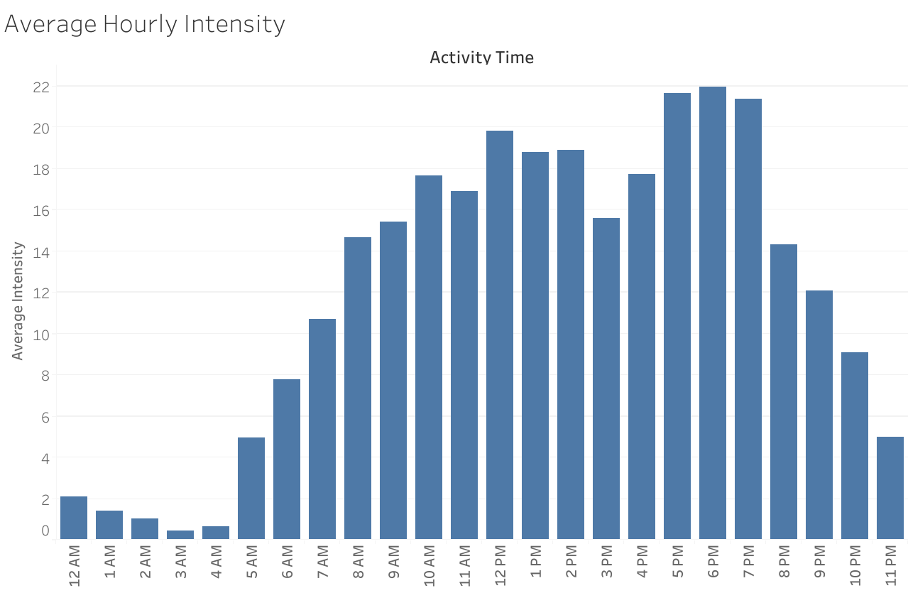

*Figure 5: Average hourly intensity*

Average intensities are paired with METs which stands for metabolic equivalents. MET is defined as the amount of oxygen consumed while at rest, that is 1 MET (Healthline, 2019). For example, 2 MET means a person is consuming two times the amount of oxygen consumed while at rest. Classifications of METs are as follows:

* <3 METs are light activities
* 3 to 6 METS are Moderate activities
* 6 METs or more are vigorous activities

Highest MET recoded is 15.7 however on average the maximum MET is less than 2 METs because only a few munities were spent doing physical activity.

Respondents clocked an average of 7600 steps a day which is about 5.5 km a day and burnt an average of 2300 kilocalories a day (estimated energy expenditure). Only 7 respondents travelled more than 10 000 steps a day (8 km) on average (refer to Figure 6 below) which is the recommended steps per day (Jennifer Huizen, 2021).

The responded for dataset 2 clocked 8284 steps per day on average and responded for dataset 3 clocked 6849 steps per day on average.

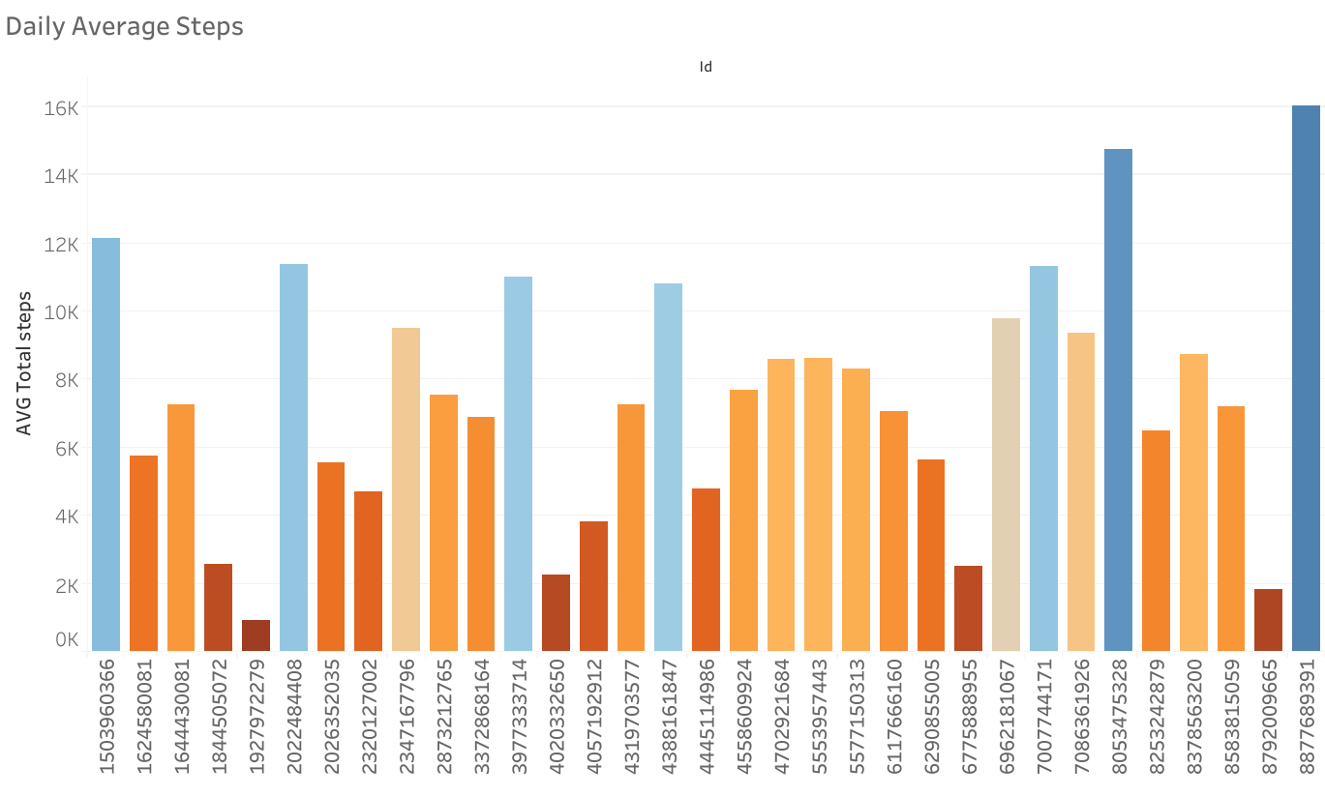

*Figure 6: Daily average steps*

24 respondents(Fitabase) monitored their sleep for an average of 17 days. On average they spent 7 hours 37 minutes in bed and about 7 hours asleep. This means they got the recommended amount of sleep assuming that all respondents were adults (Olson, 2021).

Respondent for dataset 2 tracked sleep pattern for 1674 days and respondent for dataset 3 tracked sleeping pattern for 28 days only. Responded for dataset 2 got an average of 7 hours 13 minutes of sleep and responded for dataset 2 got an average of 6 hours 17 minutes of sleep.

Only 14 respondents recorded their heart rate and from data they recorded an average of 77 beats per minute (BPM) (Table 2). Their heart rate was normal assuming that the Respondents were adults and non-athletic (Laskowski, 2020). However, there were spikes over a few seconds whereby heart rate as low as 36 BPM was recorded and a maximum of 203 BPM was recorded.

*Table 2: Average heart rate per minute*

|  |  |
| --- | --- |
| **Id**  **AverageHeartRate** | |
| 6117666160 83 | |
| 4558609924 | 81 |
| 6962181067 77 | |
| 4020332650 | 82 |
| 2026352035 93 | |
| 6775888955 | 92 |
| 2022484408 80 | |
| 8792009665 | 72 |
| 2347167796 76 | |
| 5553957443 | 68 |
| 4388161847 66 | |
| 5577150313 | 69 |
| 8877689391 83 | |
| 7007744171 | 91 |

Respondent for dataset 3 recorded an average of 68 BPM, a minimum of 47 BPM and a maximum of 150 BPM.

# Conclusion

Most users of tracking devices are female which gives Bellabeat an added advantage. The market is expected to grow which gives Bellabeat an opportunity to grow.

The conclusion and recommendations will be based on the three datasets analysed in this study. The sample size is small compared to the population that uses health trackers however, with more data from literature study it is can assist in improving Bellabeat marketing strategy.

The following are the major conclusion reached.

* Most respondents used health tracking devices consistently
* All respondents tracked calories, steps, physical activity and corresponding duration.
* 72 % of the respondents monitored their sleep pattern, 42 % monitored their heart rate and only 24 % measured their weight.
* Respondents spent more time inactive
* Respondents are mostly active in the afternoon from 17:00 to just before 20:00 and midday from 12:00 to just before 15:00
* Respondents clocked an average of 7 600 steps a day which is below the recommended steps.
* Respondents that tracked their sleeping pattern receive the recommended amount of sleep.
* 42 % of the respondents that tracked their heart health had normal heart rate.

# Recommendations (Share)

The following are the main recommendations for Bellabeat:

* Users use health tracking devices throughout the day, not only at the gym. Bellabeat marketing campaign should not only focus on health but on the beauty and the image their products portray. Their products must be fashionable.
* Bellabeat can emphasis on the protection of its clients’ private information as these devices become part of their lives.
* Most users of health device are young adults, Bellabeat can use social media as means of advertising
* Time slots for advertising can be in the early morning as people are getting ready for work as well as in the afternoon when people are leaving work and going to the gym.

* For its clients, Bellabeat can provide the following which can be their selling point:
  + Provide health campaigns that encourage healthy lifestyle. Provide its clients with comprehensive health information by showing how different health metrics work together.
  + Emphasise on the importance of tracking heartrate and send warning whenever certain thresholds are exceeded. Offer the option to link their devices to medical services in case of imminent heart attack.
  + Send training reminders before times when users are mostly active.
  + Ensure that their devices have long lasting battery so that users can use their devices for longer.
  + Give its clients comprehensive reports and tips on how to improve their lifestyles.
  + Offer reward system to its clients using their devices to improve their health.

References

Fitabase, 2018. *Fitabase data dictioneries.* [Online]

Available at: https://www.fitabase.com/resources/knowledge-base/exporting-data/datadictionaries/

Fortune Business Insights, 2021. *10 Fitness Tracker Companies Changing The Healthcare*

*Sector.* [Online]

Available at: https://www.globenewswire.com/news-release/2021/11/11/2332244/0/en/10-

Fitness-Tracker-Companies-Changing-the-Healthcare-Sector-Market-Size-Share-ForecastsTrends-Analysis-Report-with-COVID-19-Impact-by-Fortune-Business-Insights.html

Healthline, 2019. *What Exactly are METs and what you should know about them.* [Online]

Available at: https://www.healthline.com/health/what-are-mets

Jennifer Huizen, 2021. *Medical News Today.* [Online]

Available at: https://www.medicalnewstoday.com/articles/how-many-steps-should-you-takea-

day#:~:text=As%20a%20result%2C%20the%20CDC,to%20about%201.5%E2%80%932%2

0miles.

John Elflein, 2019. *Statista.* [Online]

Available at: https://www.statista.com/statistics/742448/global-fitness-tracking-andtechnology-by-age/ [Accessed 17 07 2022].

Justin Mccarthy, 2019. *Gallup.* [Online]

Available at: https://news.gallup.com/poll/269096/one-five-adults-health-apps-wearabletrackers.aspx

Laskowski, E., 2020. *Mayo Clinic.* [Online]

Available at: https://www.mayoclinic.org/healthy-lifestyle/fitness/expert-answers/heartrate/faq-

20057979#:~:text=A%20normal%20resting%20heart%20rate%20for%20adults%20ranges% 20from%2060,to%2040%20beats%20per%20minute.

Olson, E., 2021. *Mayo Clinic.* [Online]

Available at: https://www.mayoclinic.org/healthy-lifestyle/adult-health/expert-answers/howmany-hours-of-sleep-are-enough/faq-20057898 [Accessed 10 07 2022].

Sara Lebow, 2021. *Insider Intelligence.* [Online]

Available at: https://www.insiderintelligence.com/content/top-health-fitness-metrics-trackedby-us-wearable-users